### WeHeartSwift.com → <https://www.weheartswift.com/variables-constants-basic-operations/>

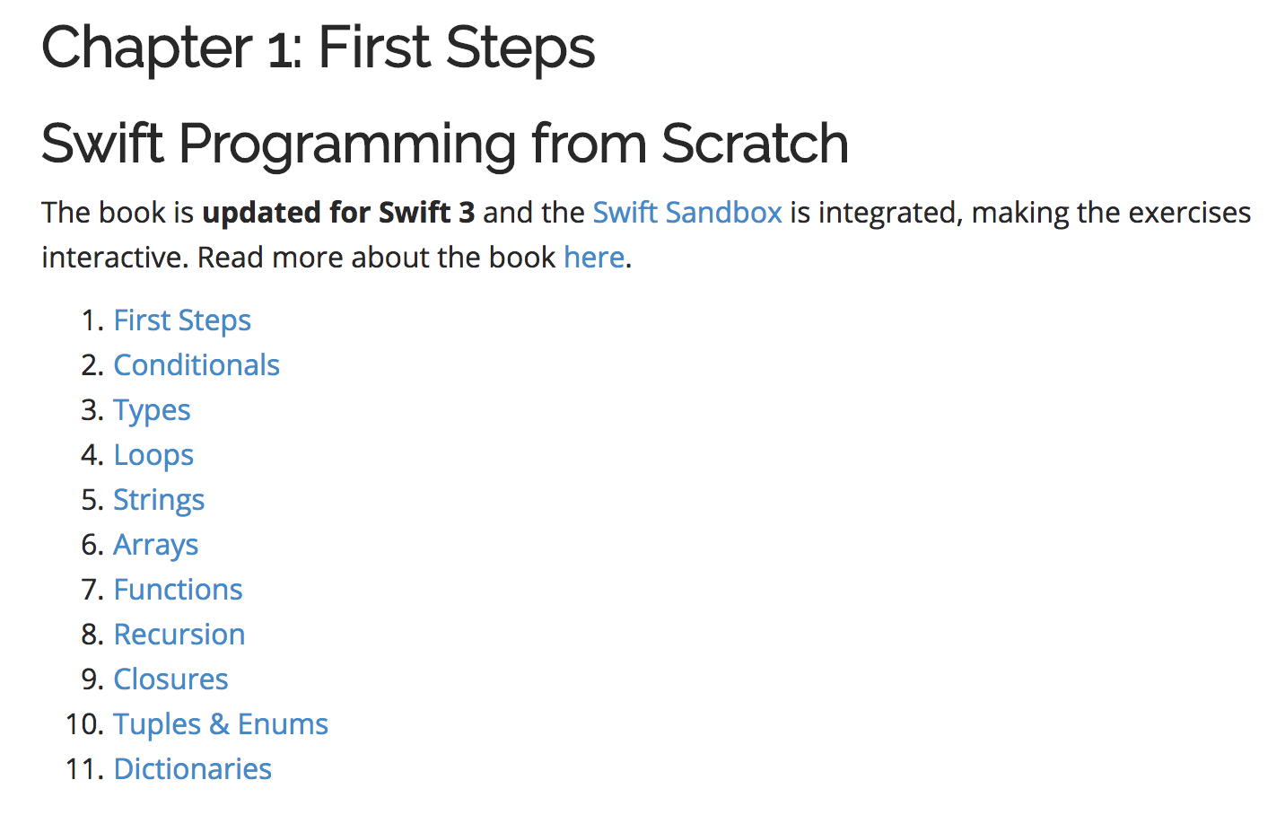

### HackingWithSwift.com → <https://www.hackingwithswift.com/read/0/overview>

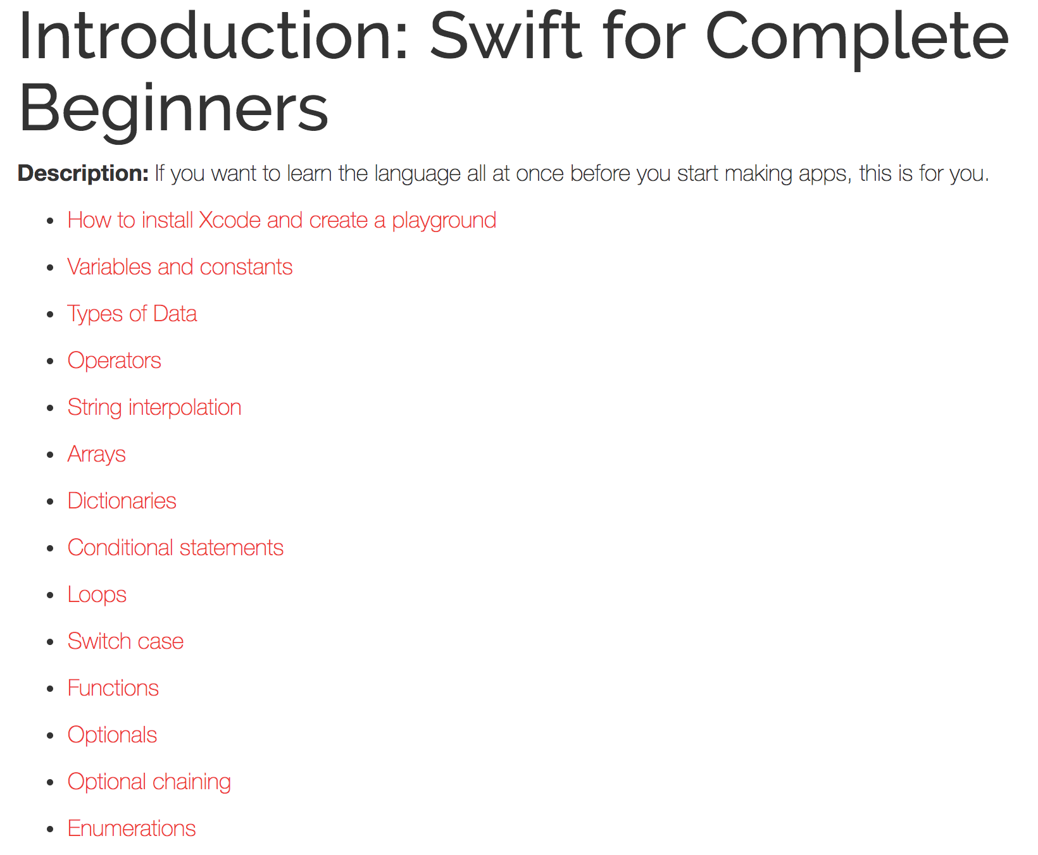

### iSwift.org → <https://iswift.org/cookbook/create-a-hello-world-app>

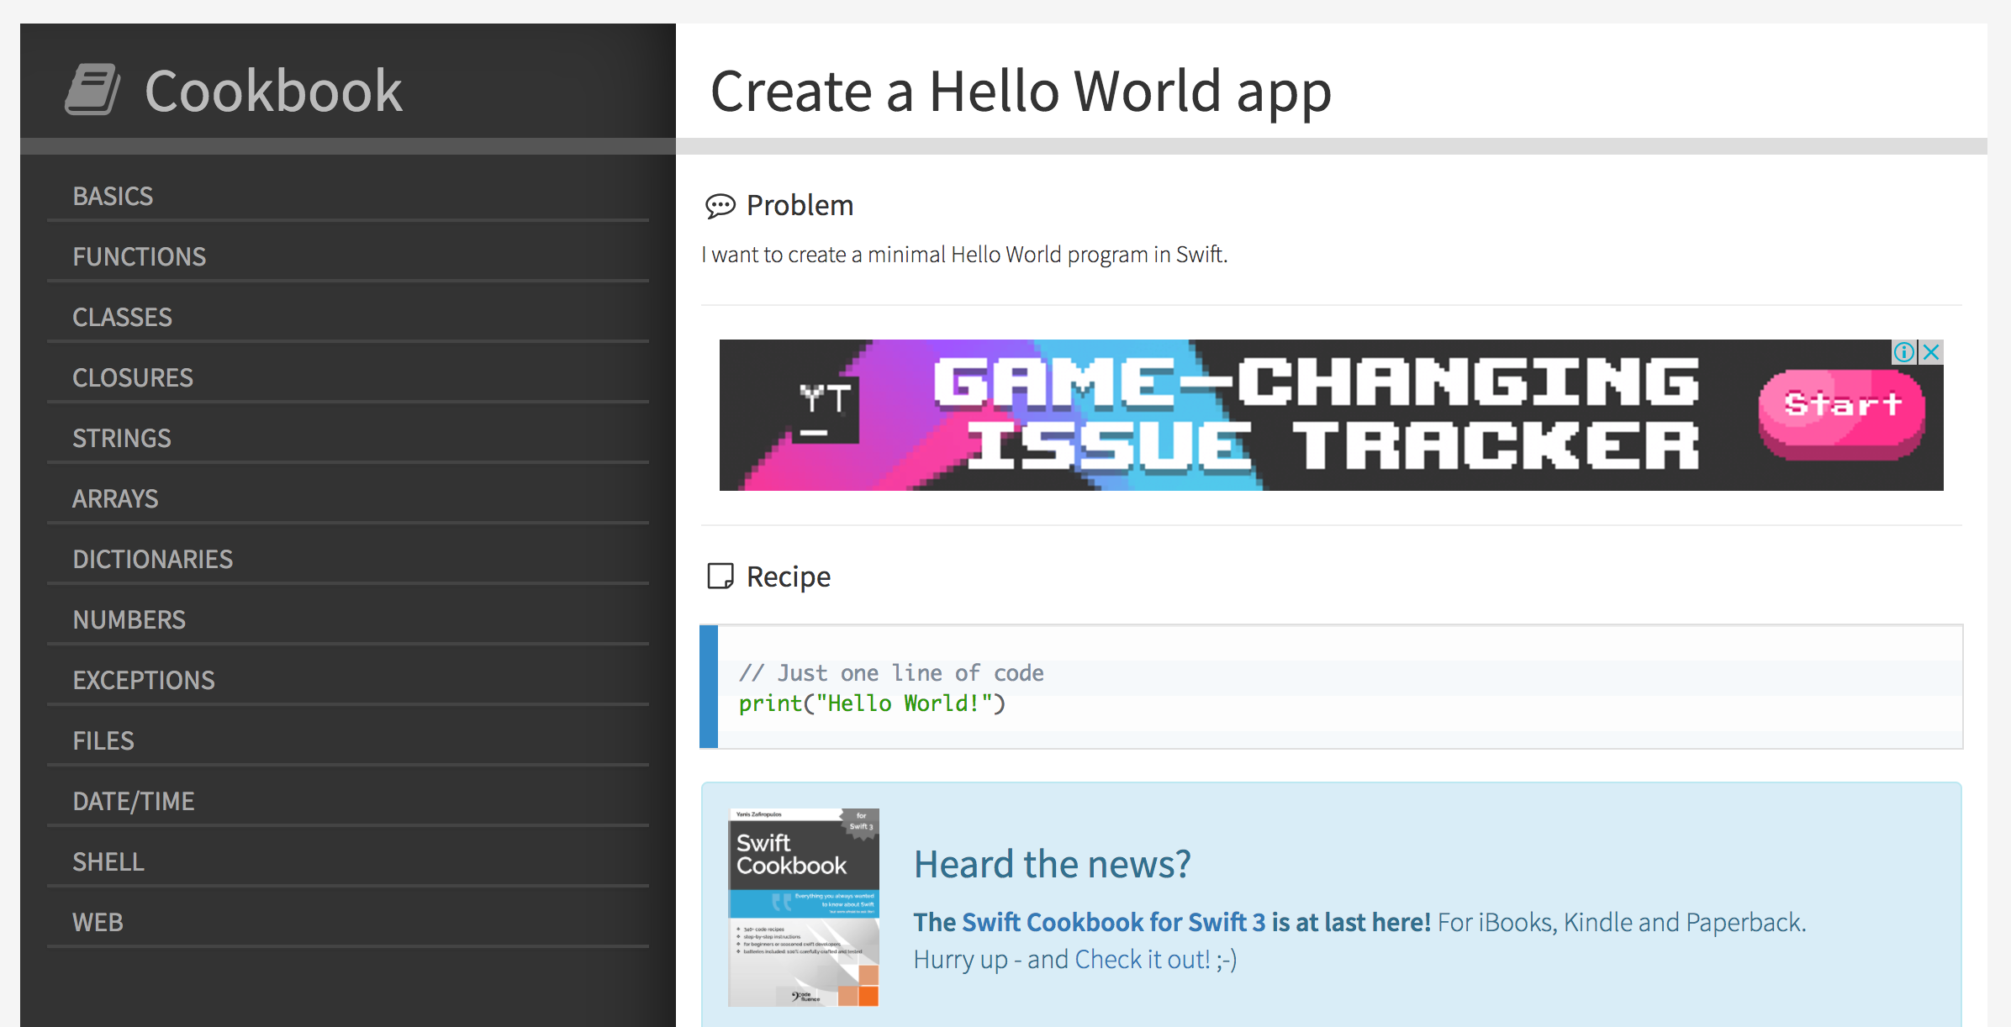

### 

### 

### AppCoda.com → <http://www.appcoda.com/learnswift/>

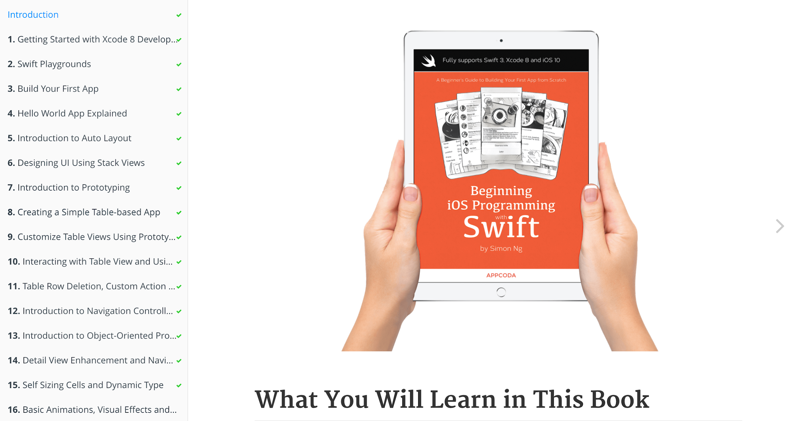

### 

### 

### RayWenderlich.com → <https://www.raywenderlich.com/category/swift>

